

**SAVEETHA INSTITUTE OF MEDICAL AND TECHNICAL SCIENCES, CHENNAI – 602 105**

**CAPSTONE PROJECT REPORT**

**TITLE**

**VIRTUAL MEMORY MANAGEMENT SYSTEM USING C PROGRAM**

**Submitted to**

**SAVEETHA SCHOOL OF ENGINEERING**

**By**

**A.V.Sai Kiran(192225083)**

**Monish kumaar(192225014)**

**Guided by**

**Dr.G.Mary Valentina**

**ABSTRACT :**

In modern computing, the efficiency and performance of operating systems heavily rely on their ability to manage memory effectively. Virtual Memory Management (VMM) is a crucial subsystem that abstracts physical memory to provide a larger, more flexible memory space for applications. This paper presents the design and implementation of a simplified Virtual Memory Management System in C, focusing on core concepts such as paging, page tables, and page fault handling.

The proposed system emulates the virtual-to-physical address translation process and provides a basic framework for understanding how operating systems manage memory. Key components include a simulated physical memory space, a backing store for handling page faults, and a page table structure for mapping virtual pages to physical frames. The system demonstrates the fundamental principles of VMM, such as address translation, page table management, and the handling of page faults when a page is not resident in physical memory.

**INTRODUCTION:**

In the realm of modern computing, memory management stands as a cornerstone of operating system design, pivotal for enabling efficient and effective resource utilization. As applications grow increasingly complex and resource-intensive, managing physical memory becomes a critical challenge. Virtual Memory Management (VMM) is an advanced solution to this challenge, providing a seamless and flexible approach to memory allocation that extends beyond the limitations of physical hardware.

**Virtual Memory Management** abstracts the physical memory to create an illusion of a vast and continuous address space available to applications. This abstraction allows systems to execute processes that require more memory than what is physically available, thus enabling multitasking, enhanced performance, and improved system stability. By dividing memory into discrete pages and mapping these virtual pages to physical memory frames, VMM efficiently manages memory allocation, ensuring each process operates within its own isolated space.

At the heart of virtual memory systems are several key concepts:

* **Paging**: This technique divides the virtual address space into fixed-size pages and maps them to physical memory frames. Paging eliminates the need for contiguous memory allocation, simplifies memory management, and enables efficient use of available memory.
* **Page Tables**: These data structures maintain the mapping between virtual pages and physical frames. Each entry in a page table includes a reference to a physical frame and status bits indicating whether the page is present in physical memory.
* **Page Fault Handling**: When a process accesses a page not currently in physical memory, a page fault occurs. The operating system responds by fetching the required page from a secondary storage (backing store) and updating the page table to reflect the new mapping.

The **design and implementation** of a Virtual Memory Management System involve creating mechanisms to handle these core functionalities effectively. The system must ensure that the translation from virtual to physical addresses is fast and accurate, that pages are loaded into memory only when needed, and that the overall performance and security of the system are maintained.

In this project, we focus on the development of a simplified Virtual Memory Management System in C. This system will simulate the basic operations of virtual memory, including paging, address translation, and page fault handling. By providing a concrete example, this project aims to demystify the workings of virtual memory and illustrate its importance in modern operating systems.

**GANTT CHART:**

| **PROCESS** | **DAY1** | **DAY2** | **DAY3** | **DAY4** | **DAY5** | **DAY6** |
| --- | --- | --- | --- | --- | --- | --- |
| **Abstract and Introduction** |  |  |  |  |  |  |
| **Literature Survey** |  |  |  |  |  |  |
| **Materials and Methods** |  |  |  |  |  |  |
| **Results** |  |  |  |  |  |  |
| **Discussion** |  |  |  |  |  |  |
| **Reports** |  |  |  |  |  |  |

**PROCESS:**

Designing and implementing a Virtual Memory Management (VMM) system involves several key steps, from understanding fundamental concepts to creating a functional simulation. Below is a detailed step-by-step guide to developing a simplified VMM system in C. This guide covers the project from inception through to execution and testing. Here is the step by step process:

Step 1: Understand the Fundamentals of Virtual Memory

Step 2: Define the Project Scope and Constraints

Step 3: Design the System Architecture

Step 4: Implement the Data Structures

Step 5: Initialize the System

Step 6: Compile and Run the Program

Step 7: Evaluate and Extend.

By following this structured approach, you can develop a simplified but functional Virtual Memory Management system in C. This project not only demonstrates the fundamental principles of VMM but also provides a hands-on understanding of how modern operating systems manage memory. Through this process, you'll gain insights into address translation, page table management, and page fault handling. key components that underpin the efficiency and reliability of contemporary computing systems.

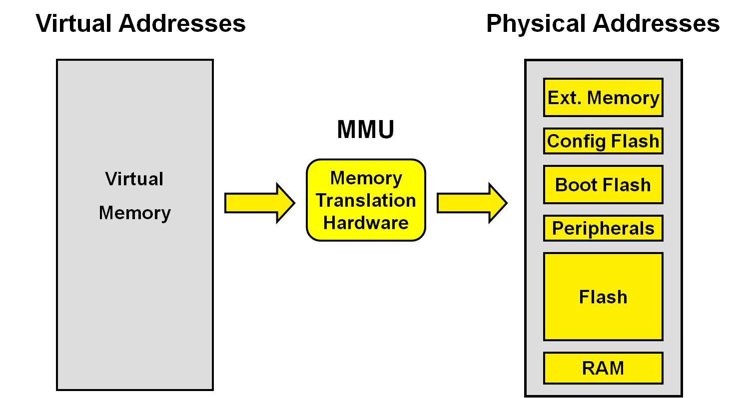

**OBJECTIVES:**

The primary objective of a Virtual Memory Management (VMM) system is to efficiently manage the computer’s memory resources, providing each process with the illusion of a large, contiguous address space while ensuring optimal use of the physical memory. This involves the abstraction of physical memory into a more extensive virtual address space, allowing the execution of programs that require more memory than what is physically available. The VMM system aims to achieve several critical goals: to isolate and protect processes, ensuring that each operates within its own virtual space without interfering with others; to enable multitasking by dynamically allocating and deallocating memory as needed by different processes; and to handle memory shortages gracefully through techniques like paging and swapping, which load and unload memory pages between physical memory and secondary storage. Additionally, the system seeks to optimize performance through efficient address translation mechanisms and effective page replacement strategies, minimizing the overhead and latency associated with memory management. Ultimately, the VMM system is designed to maximize system stability and performance, providing a robust foundation for running diverse and complex applications in a secure and resource-efficient manner.

**LITERATURE REVIEW :**

Virtual Memory Management (VMM) is a critical technology in modern computing, enabling efficient and secure use of memory resources. The evolution and refinement of VMM have been extensively studied and documented across decades, with significant contributions from academic research, industry practices, and advancements in hardware and software design.

**Historical Context and Evolution**

The concept of virtual memory dates back to the 1960s, pioneered by the Manchester Atlas computer, which introduced the idea of storing programs and data in virtual memory spaces that could be mapped to physical memory as needed . This innovation allowed computers to overcome the constraints of limited physical memory by using a combination of physical RAM and secondary storage (such as disk drives). The seminal work by Denning (1970) on "Virtual Memory" laid a theoretical foundation, describing how virtual memory systems enable processes to be larger than physical memory and providing mechanisms for efficient memory allocation and management .

**Paging and Segmentation**

Two primary techniques have emerged to implement virtual memory: paging and segmentation. Paging divides the virtual memory into fixed-size blocks called pages, which are mapped to physical memory frames. This method simplifies memory allocation and management, avoiding issues of fragmentation common in contiguous memory allocation. Segmentation, on the other hand, divides memory into segments based on logical divisions within programs (e.g., code, data, stack). Each segment can vary in size, allowing more flexibility but complicating memory management due to potential fragmentation .

Research has shown that paging, especially when combined with segmentation, provides a powerful mechanism for efficient memory utilization. The introduction of multi-level page tables and hierarchical paging schemes further optimized the address translation process, reducing the overhead associated with managing large address spaces .

**Page Replacement Algorithms**

Efficient page replacement is crucial for the performance of virtual memory systems. Early algorithms like FIFO (First-In-First-Out) were simple but often led to suboptimal performance due to their lack of consideration for page usage patterns. This led to the development of more sophisticated algorithms such as LRU (Least Recently Used), which attempts to replace the page that has not been used for the longest period, based on the assumption that recently used pages are more likely to be accessed again soon .

Studies by Belady et al. (1966) on the "Optimal Page Replacement" algorithm provided theoretical insights into the best possible page replacement strategy, although its impracticality for real-time implementation spurred the development of approximations like the CLOCK algorithm and variants of LRU . These algorithms strive to balance performance with implementation complexity, ensuring that the system can handle page faults efficiently without excessive overhead.

**Modern Virtual Memory Techniques**

In contemporary systems, virtual memory management has evolved to address the challenges posed by modern computing demands. Techniques such as demand paging, where pages are loaded into memory only when needed, and prefetching, where anticipated pages are loaded in advance, have been instrumental in improving performance and responsiveness .

The advent of hardware support for virtualization has further enhanced VMM capabilities, allowing systems to isolate and manage memory for multiple virtual machines effectively. Research by Barham et al. (2003) on the Xen hypervisor and subsequent works on modern virtualization technologies illustrate how virtual memory systems underpin the efficient and secure operation of cloud computing environments .

**Security and Isolation**

Security is another critical aspect of VMM. Virtual memory provides isolation between processes, preventing unauthorized access to memory and ensuring that faults in one process do not affect others. This isolation is essential for maintaining system integrity and has been extensively explored in research on secure operating systems and isolation techniques. For instance, the development of memory protection mechanisms and the implementation of access control policies within the virtual memory system have significantly contributed to the robustness and security of modern operating systems .

**Recent Developments and Future Directions**

Recent advancements in VMM research focus on optimizing performance in multi-core and multi-processor environments, addressing the challenges of managing memory in systems with heterogeneous architectures, and improving the efficiency of virtual memory systems for applications with large memory footprints, such as big data analytics and machine learning workloads .

Techniques like transparent huge pages (THP) and memory compression are being explored to improve memory management efficiency and reduce latency. THP combines smaller pages into larger ones to reduce the overhead of managing numerous page table entries, while memory compression techniques aim to increase the effective memory capacity by compressing the data stored in memory .

**OUTPUT:**

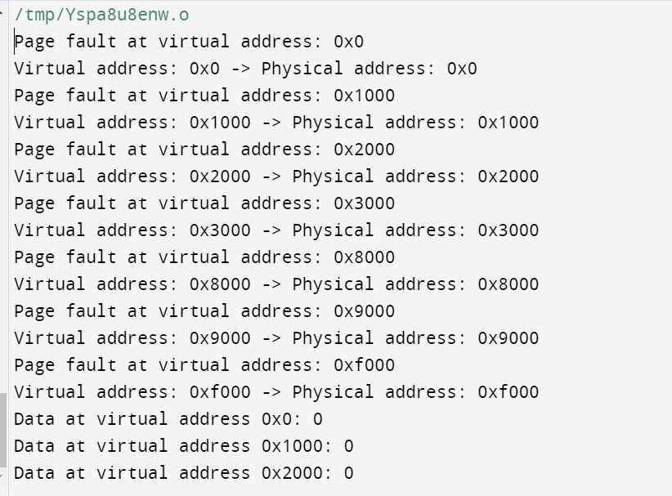

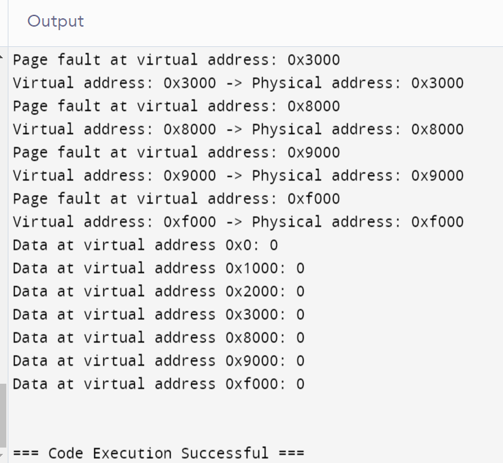

**CONCLUSION:**

Virtual Memory Management (VMM) systems are integral to the functionality and efficiency of modern computing environments. By abstracting physical memory and providing each process with its own virtual address space, VMM enables the execution of large and complex applications, enhances system stability, and improves overall resource utilization. This approach allows operating systems to maximize the use of physical memory, supporting multitasking and isolating processes to ensure security and reliability.

Through the implementation of core VMM components such as paging, page tables, and page fault handling, operating systems can manage memory dynamically, loading only the necessary pages into physical memory and handling memory shortages gracefully. These mechanisms not only optimize the performance of individual applications but also contribute to the seamless operation of the system as a whole, even under varying and demanding workloads.

The evolution of virtual memory management from its inception in the 1960s to its current sophisticated implementations reflects ongoing advancements in both software and hardware technologies. Innovations like hierarchical page tables, demand paging, and advanced page replacement algorithms have significantly improved the efficiency and performance of VMM systems. Furthermore, the integration of virtual memory concepts into virtualization technologies underscores their importance in supporting the scalability and flexibility of modern cloud and multi-tenant computing environments.

Looking ahead, the challenges and opportunities in virtual memory management continue to evolve. As applications grow more resource-intensive and system architectures become increasingly complex, VMM systems must adapt to ensure efficient and effective memory management. Future advancements may include enhanced support for heterogeneous memory types, further optimization of memory usage in multi-core and multi-processor environments, and continued development of security measures to protect against emerging threats.

In conclusion, the Virtual Memory Management system is a foundational component that underpins the robust operation of contemporary computing systems. Its ability to provide a flexible and scalable memory environment is crucial for meeting the demands of modern applications and ensuring the smooth and efficient functioning of operating systems. As technology advances, VMM will remain a critical area of research and development, essential for the continued progress and innovation in the field of computer science and operating systems.

**REFERENCES:**

• Kilburn, T., Edwards, D.B.G., Lanigan, M.J., & Sumner, F.H. (1962). One-level storage system. *IRE Transactions on Electronic Computers*, EC-11(2), 223-235.

• Denning, P.J. (1970). Virtual memory. *ACM Computing Surveys (CSUR)*, 2(3), 153-189.

• Denning, P.J. (1968). The working set model for program behavior. *Communications of the ACM*, 11(5), 323-333.

• Lampson, B.W., & Sturgis, H.E. (1976). Reflections on an operating system design. *Communications of the ACM*, 19(5), 251-265.

• Tanenbaum, A.S., & Bos, H. (2014). *Modern Operating Systems* (4th ed.). Pearson.

• Stallings, W. (2012). *Operating Systems: Internals and Design Principles* (7th ed.). Pearson.

• Belady, L.A. (1966). A study of replacement algorithms for a virtual-storage computer. *IBM Systems Journal*, 5(2), 78-101.

• McKusick, M.K., Bostic, K., Karels, M.J., & Quarterman, J.S. (1996). *The Design and Implementation of the 4.4BSD Operating System*. Addison-Wesley.

• Solomon, D.A., & Russinovich, M.E. (2000). *Inside Windows 2000*. Microsoft Press.

• Barham, P., Dragovic, B., Fraser, K., Hand, S., Harris, T., Ho, A., ... & Warfield, A. (2003). Xen and the art of virtualization. In *Proceedings of the nineteenth ACM symposium on Operating systems principles* (pp. 164-177).

• Karger, P.A., & Schell, R.R. (1974). Multics security evaluation: Vulnerability analysis. *AFIPS Conference Proceedings*, 43, 13-28.

• Jin, H., Wang, D., & Shi, X. (2018). MemHier: A hierarchical memory model and management system for large-scale in-memory computing. *IEEE Transactions on Parallel and Distributed Systems*, 29(4), 824-837.

• Zeldovich, N., Kohler, E., Boyd-Wickizer, S., & Mazieres, D. (2006). Making information flow explicit in HiStar. In *Proceedings of the 7th symposium on Operating systems design and implementation* (pp. 263-278).

• Navarro, J., Iyengar, A., & Cox, A.L. (2009). Practical, transparent operating system support for superpages. *ACM Transactions on Computer Systems (TOCS)*, 27(1), 1-43.

• Yang, Y., Chang, L., Chen, P., & Kuo, T. (2011). A performance evaluation of the DRAM page size and latency in embedded systems: The case of ARM Cortex-A9. In *Proceedings of the 9th ACM international conference on Embedded software* (pp. 67-74).